Task 1 Week 1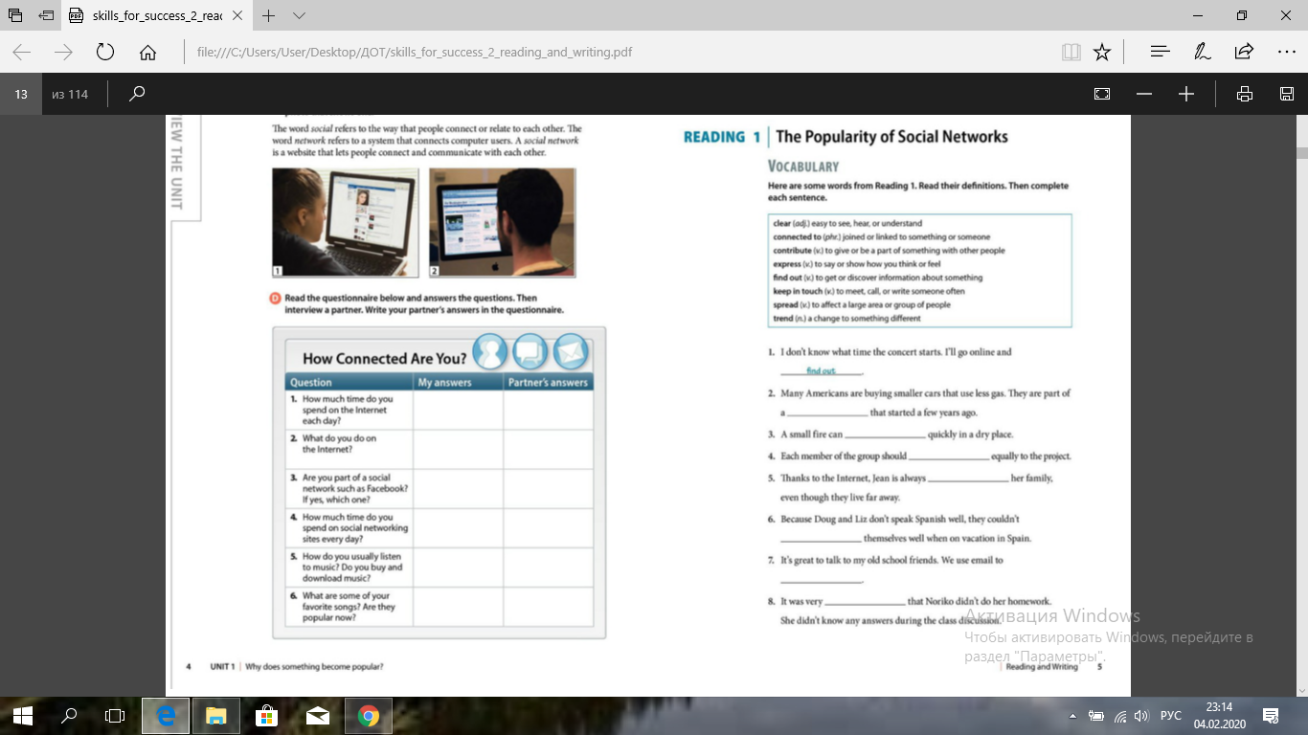
Fill in the gaps with suitable words given above

